**SOFT SKILL ASSIGNMENT MODULE-1**

1. **Thank you Email**

Subject: Thank you for the promotion!

Dear Mrs sunil shah,

I wanted to thank you for my recent promotion to as a manager and let you know how much I appreciate your support. It's such a great opportunity that I've looked forward to for some time and I'm grateful for your confidence in my abilities.

I'm grateful for giving me opportunity for manage all projects. I look forward to change old pattern off manage and add some rule for employee and make you proud with this new position.

Thanks again for your help. I'm truly grateful for your support

Sincerely ,

Karan chandarana

**2. Letter of Apology**

Dear Principal Rahul sir ,

I hope this letter finds you well. I am writing to sincerely apologize for the late submission of my assignment titled " make a HLR ", which was due on 5 JULY . I deeply regret not being able to submit it on time and take full responsibility for the delay.

My late submission was due to I have a family function so I am not available for 7 days and go out of station for attend very big function of grating ceremony . I understand that timely submissions are essential for maintaining discipline and fairness, and I truly regret any inconvenience this may have caused.

I have now completed the assignment and am ready to submit it. I will manage my time better in the future to ensure this does not happen again. If there is any penalty for the delay, I fully accept it and will improve my academic responsibility.

Once again, I apologize for this mistake and appreciate your understanding. Thank you for your time and consideration.

Sincerely ,

Karan chandarana

**3.Reminder Email**

Subject line: Appointment Reminder for deal confirmation

Dear akash gupta,

Just a reminder from sardar print and pack pvt . ltd about your appointment on 09/07/2025 at morning 10 o’clock.

To reschedule, please respond to this email or call karanchandarana2918@gmail.com.

We look forward to welcoming you soon!

Regards,  
Team sardar print and pack pvt.ltd

**4. Quotation Email**

Subject: Quotation Email for company bill

Dear Jignesh sardhara,

I hope this email finds you well. My name is pethani akhil and I am the operator of your packing section at sardar print and pack pvt.ltd.

We are currently in the process of maintain the all side pasting machine and folding machine to buy a new part and other products.

We look forward to receiving your quotation and working with you in the future.

Warm regards,

Karan chandarana

There is a copy of quotation .

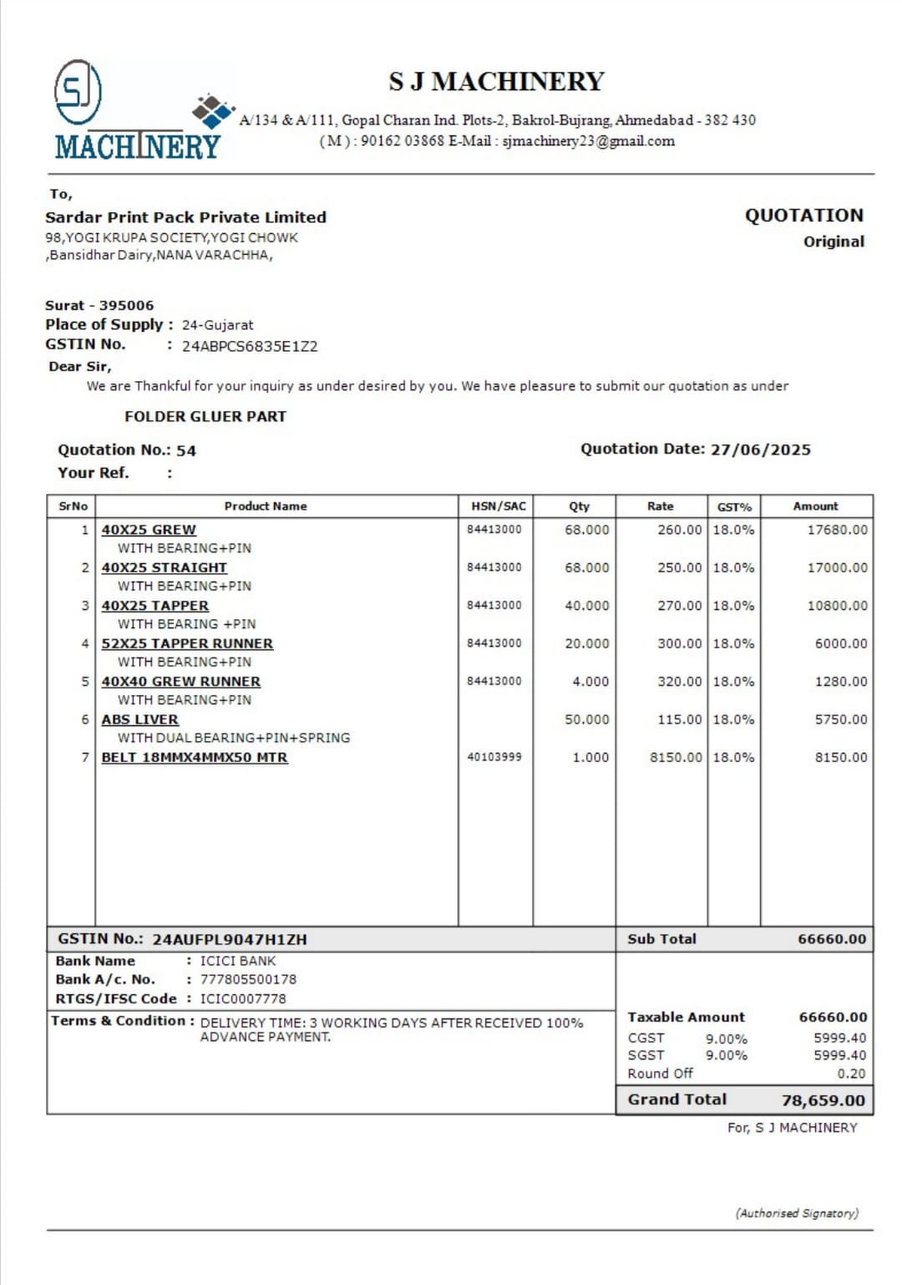

**5. Resignation Email**

Subject : Resignation akhil pethani

Dear Rahul sir,

Please accept this email as formal notice of my resignation from my position as QA at Tops Technology, effective 07 July, 2025.

I am grateful for the opportunities, membership and support I’ve received here. My time at Tops Technology has been instrumental in my professional growth and I value the relationship and experiences I’ve gained.

To ensure a smooth transition, I am happy to assist in training my replacement, documenting processes and completing current projects before my departure.

Thank you again for everything. I wish you and the team continued success, and hope we can stay in touch.

Your Sincerely,

Karan chandarana